Central university of Haryana

Department of computer science & engineering under SOET



python lab

(BT CS 526)

Lab-2

.  

Submitted by :- submitted to :-

Ponnaganti pavan kumar anant rajee bara

ROLL NO: 202102

# Lab-2: Write a function that returns all the permutation of the given string of length 3.

**Code:**

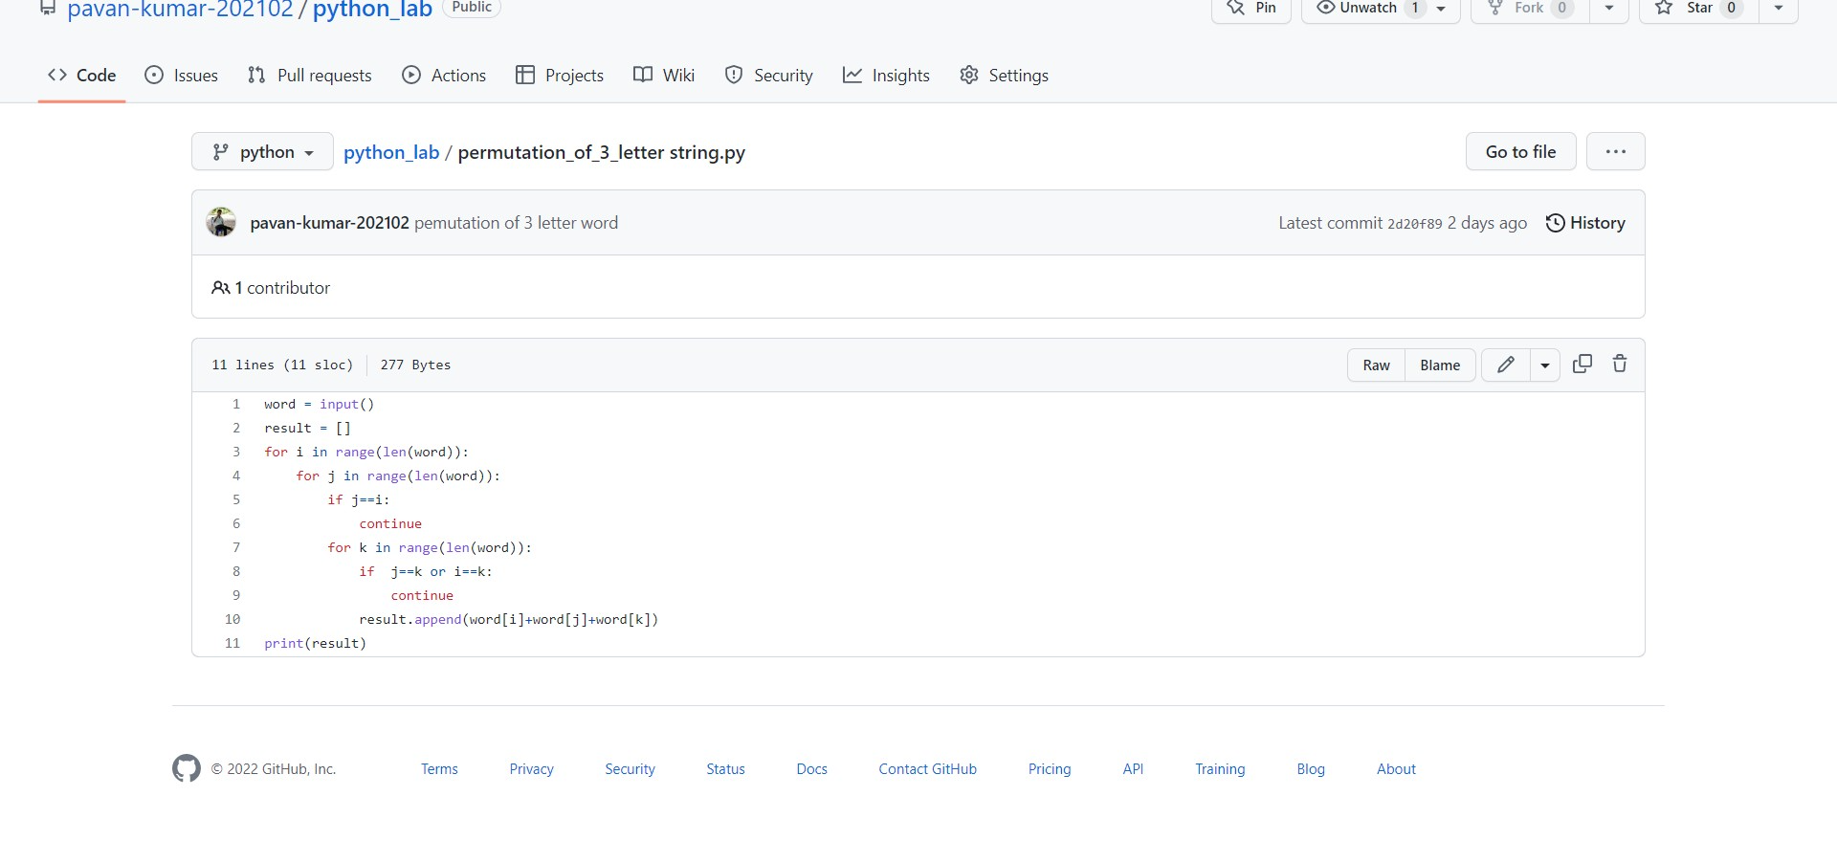

**Output:**



**Github link:**

<https://github.com/pavan-kumar-202102/python_lab/blob/python/permutation_of_3_letter%20string.py>